Teaching Notes and Suggested Activities
Compliers Barbara Griffith and Tricia Kenyon
1 Animal’s names.
Animal | Name pattern | Examples
Zebras | Males called Zeb, females called Zed | Zeb, Zed
Antelopes | All names start with ‘j’ | Julie, Joanne,  Jethro
Giraffes
Lions
Elephants
Snakes |  | S,V ,P,
Monkeys

2 The Animals.
Complete the table
Animal | Looks like | Group name | Would Zeb be scared of this animal? Why?
Zebras | Black and white stripes live in herds | herd
Antelopes | Brown with two horns, can leap high |  | No, similar size to him and would run away
Giraffes
Lions |  | Pride
Elephants
Snakes
Monkeys

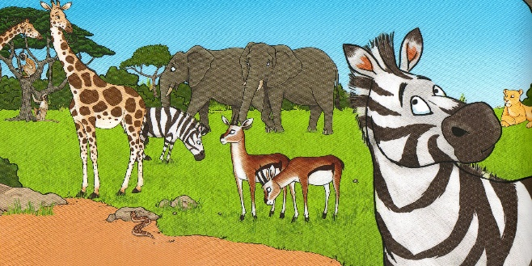

3 I am unique.
In what ways are you and your friend the same, and different?

US
-School
-Clothes
-2 brothers
John
Black hair
Plump
rugby
ME
Blonde
Tall
soccer

4 Our names
A The names of the animals in the book conformed to different patterns, can you find other names that fit into these specific patterns?
B Can you identify a pattern for your name and can you think of some other examples that fit your pattern? EG Sam Sam-Sally, Sam-Pam, Sam-Tom
C Who chose your name? Is it a family/whanau name?
D What does your first name mean? Where does your name come from?
E Why do we have more than one name?
Websites with information.
hhtps://www.behindthename.com
ww.heraldtimesonline.com/2010/06/05 Why do we have names?

5 How names are used, do some research.
A Why are names used in identifying weather patterns? How do they choose names for Tornados?
B Why are boats given names?
C What are the top 50 male or female names used in New Zealand?
6 A thought…
Why is it important to have an individual name?
Does a name determine the character of a person?

7 Write a sequel to this story, using these characters and this setting. What would you call this book?
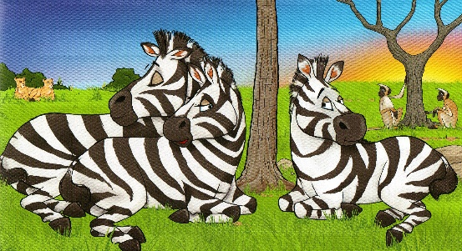

8 Write to the author and/or illustrator to ask a question, offer an opinion or make constructive criticism.

